Jenkins 105

-> Jenkins integration with Maven

=> Jenkins Job to pull Github project

Step 1: Go to `manage jenkins` and install a `maven integration` plugin.

Step 2: Also, check if `git` specific plugins are installed in jenkins

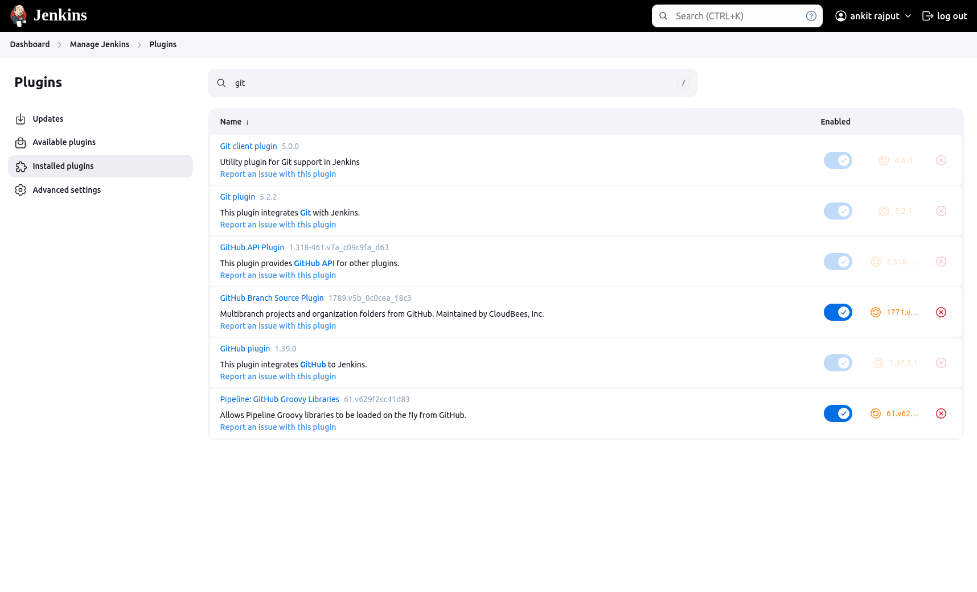

Step 3: Create a new jenkins job by clicking on `New item` and select it as a `Freestyle project`.

Step 4: Under Source Code Management (SCM), select `Git`

Screenshot:

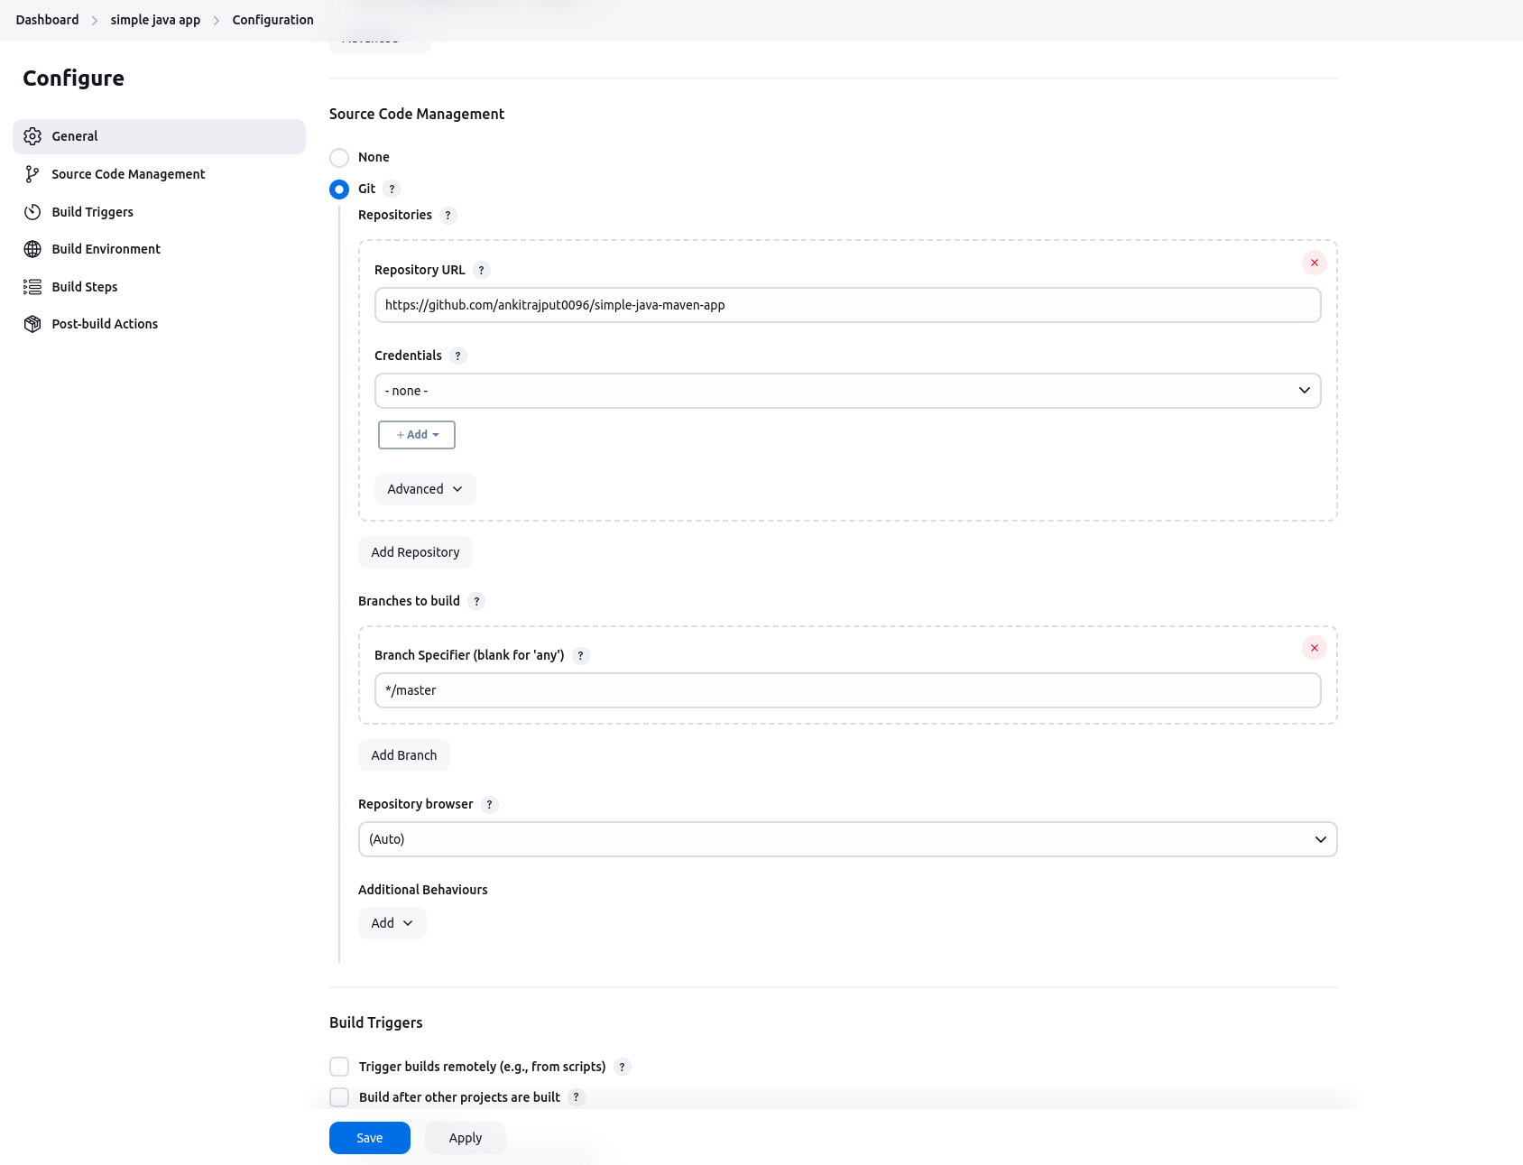

Step 5: Save the job and run it

Awesome !! now your jenkins server is able to pull the latest code in master branch for the mentioned project.

Now, let’s build this simple java project

=> Way to build the simple java project via Maven in Jenkins

Step 1: go to `manage jenkins` and go inside `tools`

Step 2: In this, under `Maven Installations`, add maven object

Screenshot:

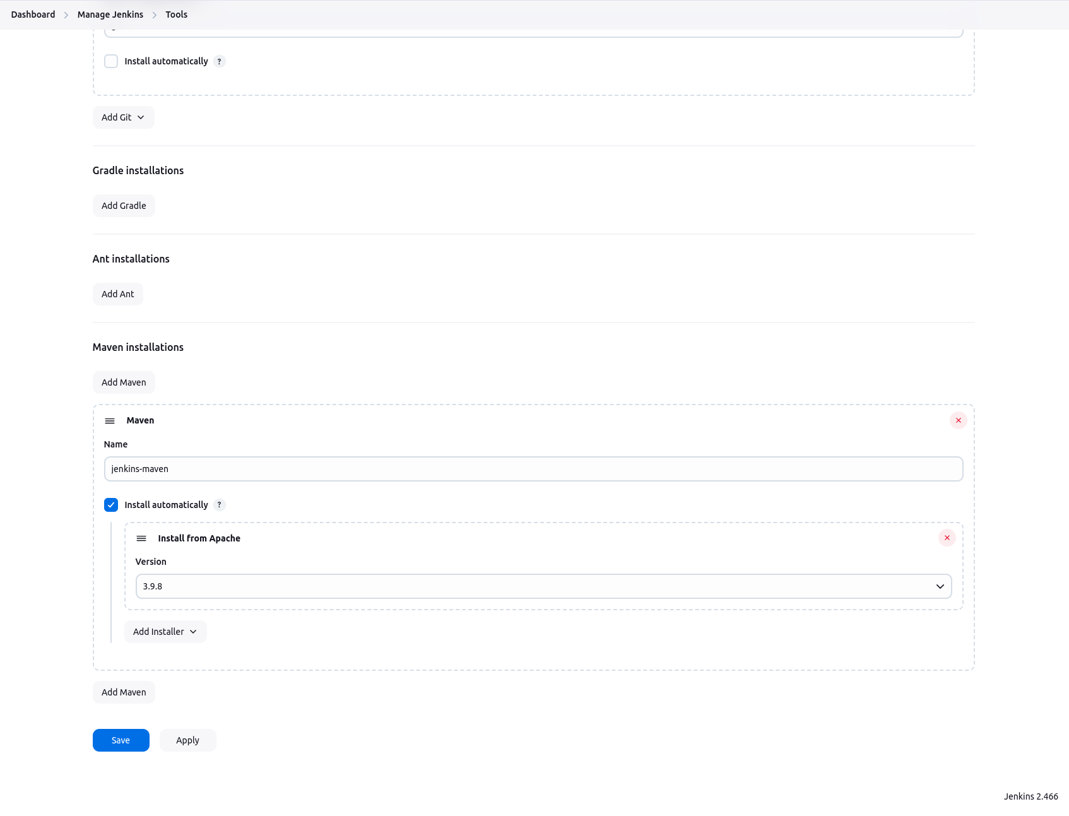

Step 3: Save these changes.

Step 4: Now, go to the `simple java app` and click on configure.

Step 5: Under `Build Steps`, click on `Invoke top-level Maven targets`.

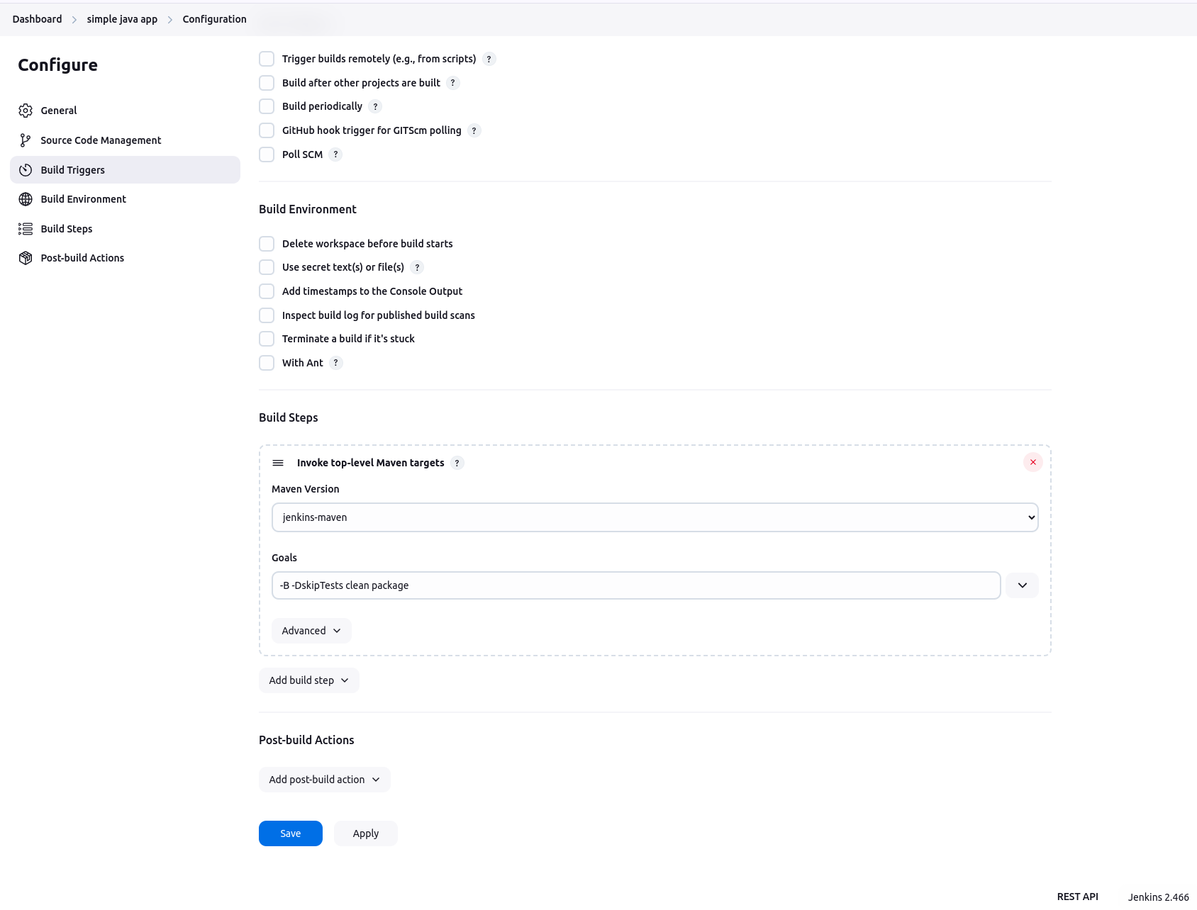

(NOTE: select the maven object created at step 2)  
Step 6: Save and run the job and analyze its logs.

Awesome !! now we are able to build the simple java project via jenkins job.

Okay, now let’s run tests of the simple java project

=> Way to run the tests in the simple java project via jenkins maven.

Step 1: Again go back to the `configure` section of simple java app jenkins job.

Step 2: Under Build Steps, again add one more step as `Invoke top-level Maven targets`

Screenshot:

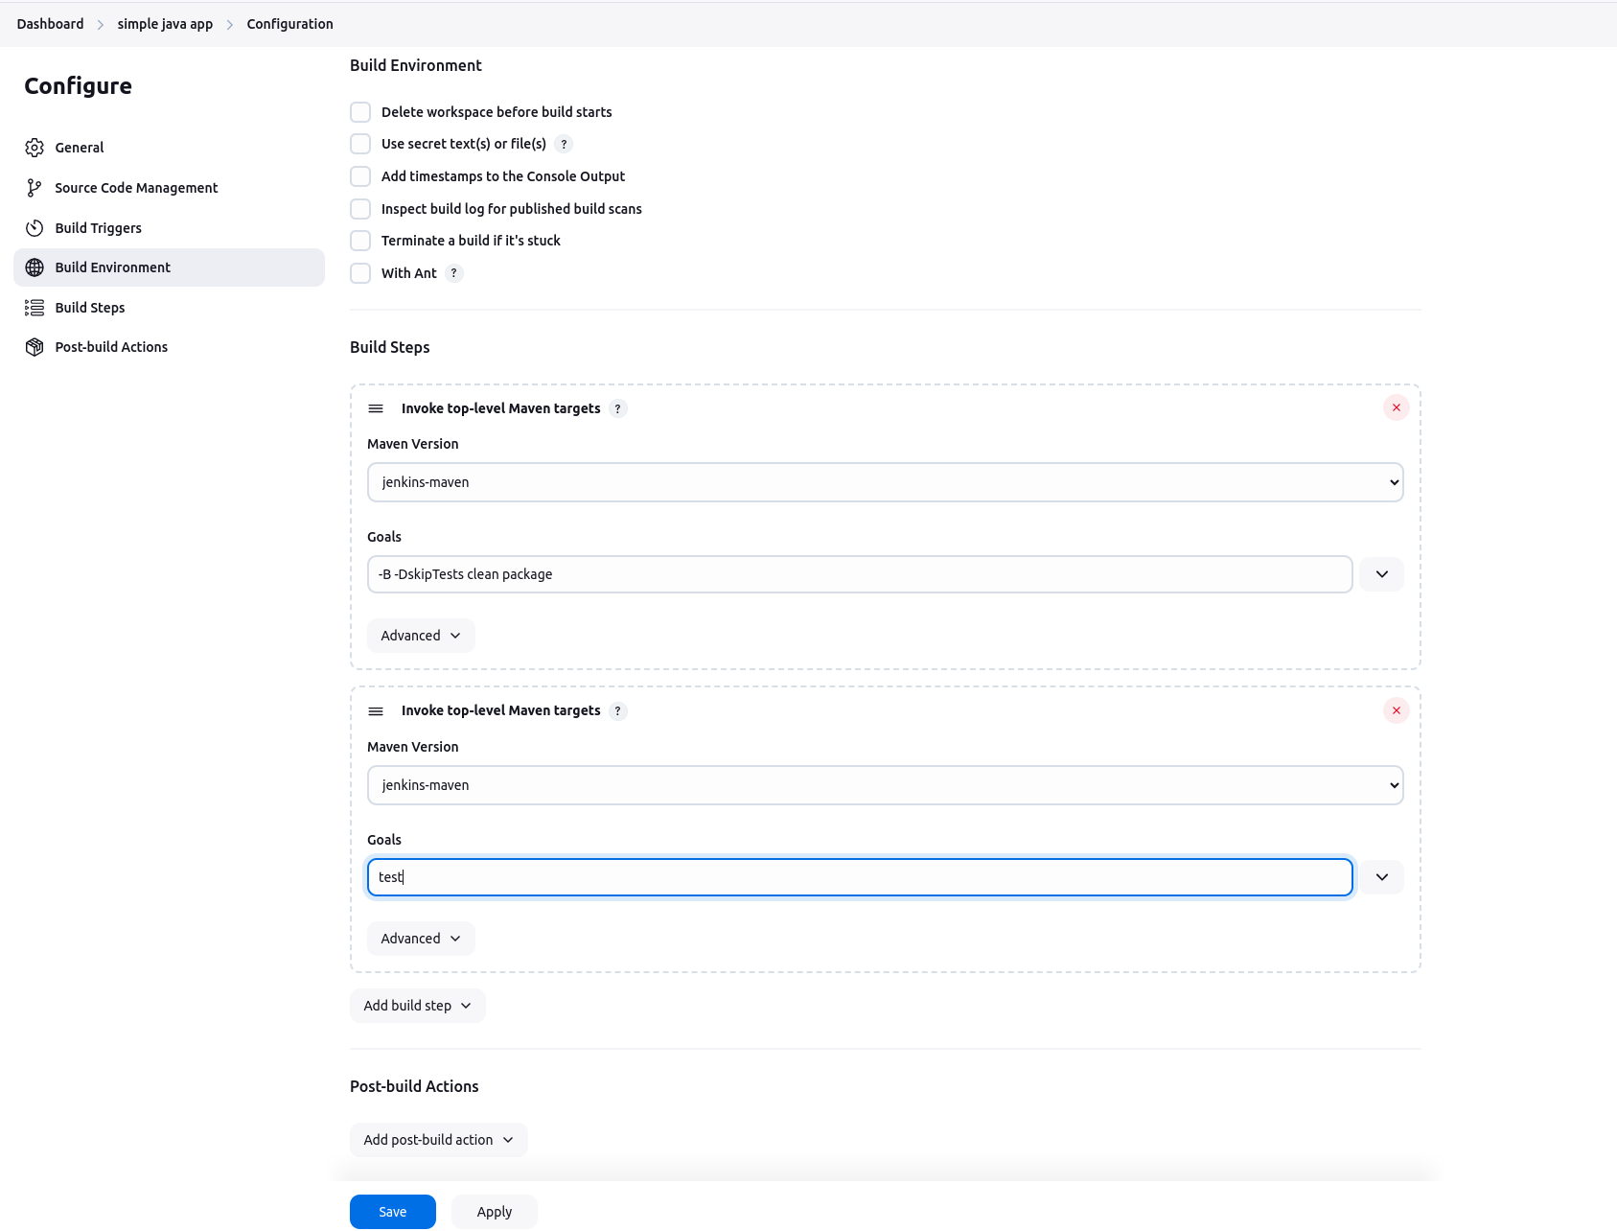

Step 3: Save the job and build it. Again observe the logs of the job.

Awesome !! now we are successfully able to run the tests associated to the simple java application.

=> Way to add result of testing using graph

Step 1: Go to the `configure` section of simple java app jenkins job.

Step 2: Under `Post-build Actions`, click on `Publish Junit test result report`

Screenshot:

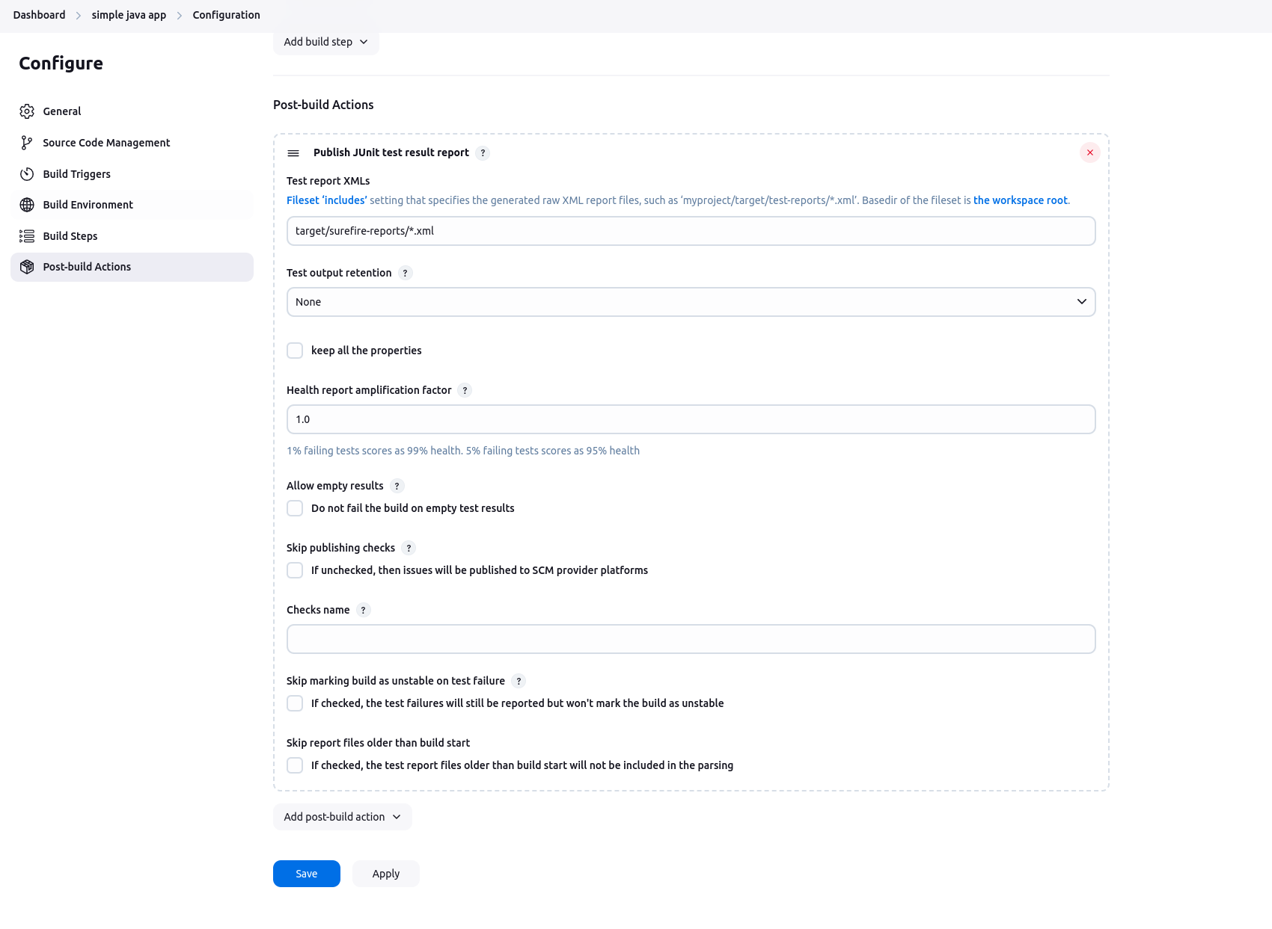

(NOTE: the pattern `target/surefire-reports/\*.xml` will pick the files which contains the results of testcases run of the simple java application during maven build)

Step 3: click on `Save` the job and re-run the job 2 times more.

Step 4: In the simple java app jenkins job dashboard, you will see the trends of test cases run in the form of graph.

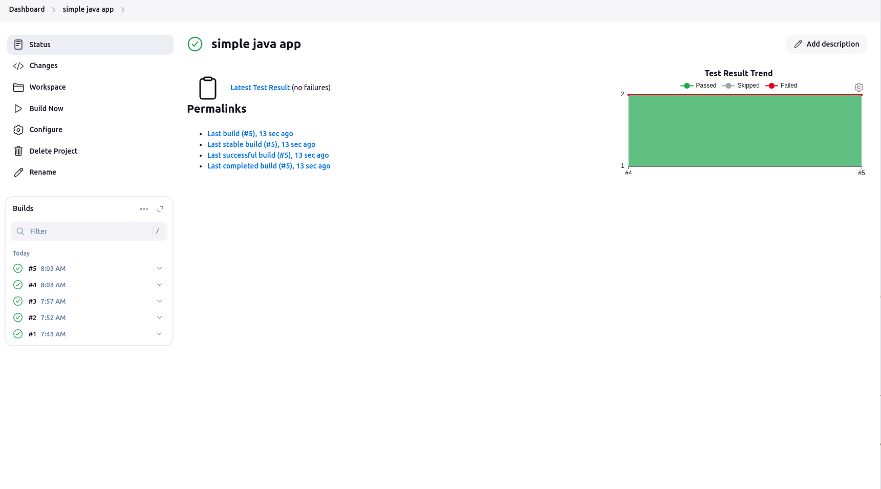

=> Way to archive the last successful artifact of the application in Jenkins job

Step 1: Go to the `configure` section of simple java app jenkins job.

Step 2: Under `Post-build Actions`, click on `Add post-build action` and select `Archive the artifacts`

Screenshot:

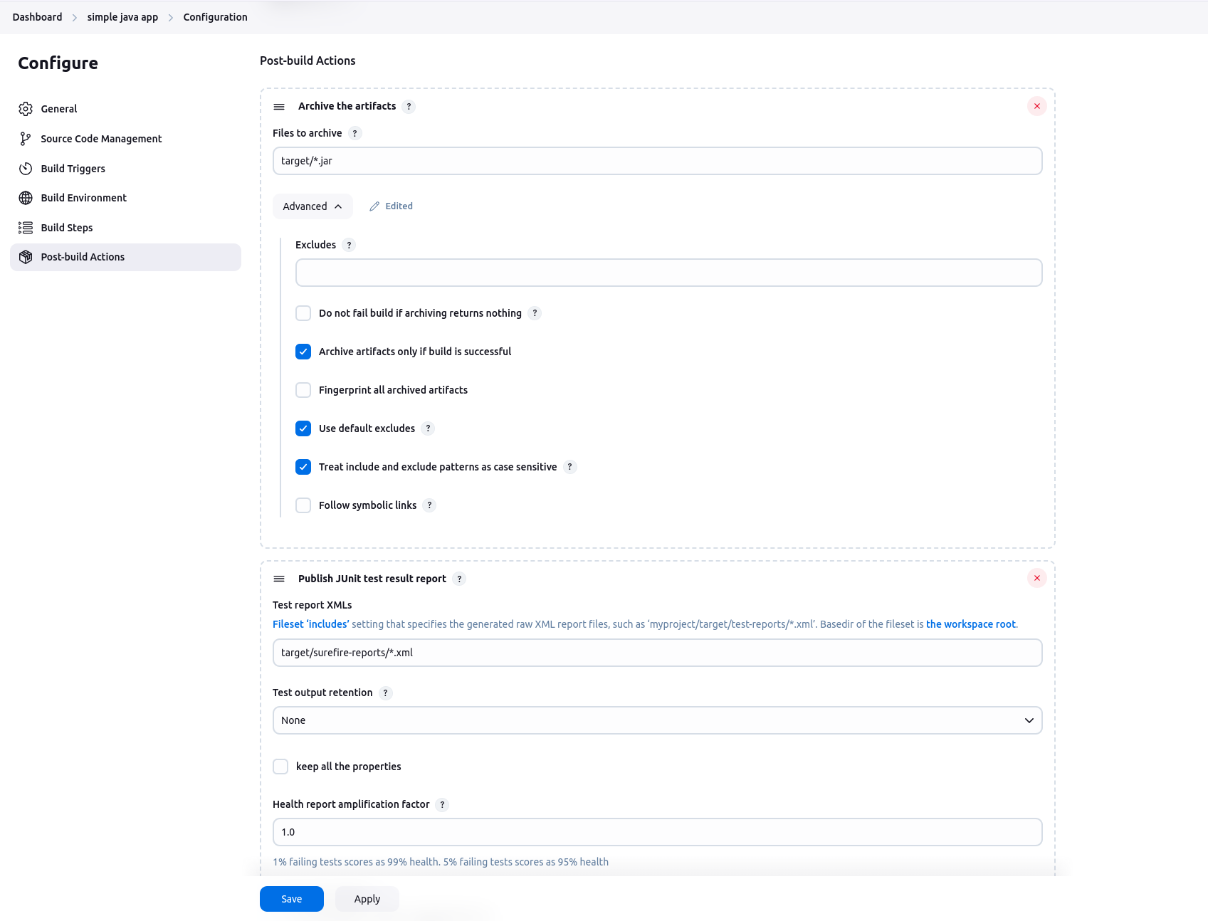

(NOTE: the patterhn `target/\*.jar` will pick the artifact jar created during the building of simple java application)

Step 3: click on Save and re-run the job.

Step 4: the Dashboard of the simple java app jenkins job will contain the artifact of the simple java application, which is built successfully.

